*Draft*

**VACCINE LOGISTICS**

**MANAGEMENT INFORMATION SYSTEM**

Barcode Scanner Application Manual

September, 2014





**Table of Contents**

[Revision History 6](#_Toc401916238)

[List of Acronyms 7](#_Toc401916239)

[Overview 9](#_Toc401916240)

[GS1 Standards 9](#_Toc401916241)

[The Roles Standards Play 10](#_Toc401916242)

[Why Choose the GS1 System of Standards 10](#_Toc401916243)

[How GS1 Standards are made 13](#_Toc401916244)

[GS1 Automatic Identification Standards 14](#_Toc401916245)

[Global Trade Item Number (GTIN) 14](#_Toc401916246)

[**Batch Number** 15](#_Toc401916247)

[**Expiration Date** 15](#_Toc401916248)

[**Serial Number** 15](#_Toc401916249)

[Overview 16](#_Toc401916250)

[Stock Tracking Through Barcode Scanner Application 16](#_Toc401916251)

[Introduction 17](#_Toc401916252)

[Overview 18](#_Toc401916253)

[Bar-coding Situation on Vaccines in EPI Stores 19](#_Toc401916254)

[GS1-Data Matrix Standard 2D Barcodes 19](#_Toc401916255)

[1D Non-GS1 or Standard Barcodes 20](#_Toc401916256)

[No Barcodes 21](#_Toc401916257)

[Assumptions 21](#_Toc401916258)

[System Requirements 22](#_Toc401916259)

[Browser Support 22](#_Toc401916260)

[User Roles 23](#_Toc401916261)

[Barcode Scanner Application User Roles 23](#_Toc401916262)

[National User 24](#_Toc401916263)

[Provincial User 25](#_Toc401916264)

[Administrator 26](#_Toc401916265)

[Step-by-Step 27](#_Toc401916266)

[Barcode Application Login 27](#_Toc401916267)

[Main Menu 29](#_Toc401916268)

[Sub Menu 30](#_Toc401916269)

[Stock Tracking 32](#_Toc401916270)

[National and Provincial User 32](#_Toc401916271)

[Stock Placement 32](#_Toc401916272)

[**Stock Receive (vLMIS web-based Application)** 33](#_Toc401916273)

[**Stock Placement (Barcode Scanner Application)** 40](#_Toc401916274)

[Stock Picking 45](#_Toc401916275)

[**Stock Issue (vLMIS web-based Application)** 45](#_Toc401916276)

[**Stock Picking (Barcode Scanner Application)** 49](#_Toc401916277)

[Stock Transfer 54](#_Toc401916278)

[**Location Status (vLMIS web-based Application)** 54](#_Toc401916279)

[**Internal Transfer (Barcode Scanner Application)** 57](#_Toc401916280)

[Locations Status 63](#_Toc401916281)

[**Location Status (vLMIS web-based Application)** 63](#_Toc401916282)

[**Location Status (Barcode Scanner Application)** 65](#_Toc401916283)

[VVM Stage 67](#_Toc401916284)

[**Set VVM Stage (vLMIS web-based Application)** 67](#_Toc401916285)

[**Update VVM Stage (Barcode Scanner Application)** 69](#_Toc401916286)

[Search Batch 72](#_Toc401916287)

[**Batch Management (vLMIS web-based Application)** 72](#_Toc401916288)

[**Search Batch (Barcode Scanner Application)** 74](#_Toc401916289)

[Search Products 76](#_Toc401916290)

[Upload 78](#_Toc401916291)

# Revision History

|  |  |  |  |
| --- | --- | --- | --- |
| **Name** | **Date** | **Reason For Changes** | **Version** |
| Pakistan Field Office | 15 September 2014 | First Draft | 1.0 |
| Pakistan Field Office | 10 October 2014 | Additions to Stock Picking | 1.1 |
| Pakistan Field Office | 20 October 2014 | Additions to VVM stage | 1.2 |

# List of Acronyms

|  |  |
| --- | --- |
| CCEM | Cold Chain Equipment Manager |
| GOP | Government of Pakistan |
| HF | Health Facility |
| ICT | Information Communications Technologies |
| IM | Inventory Management |
| IT | Information Technology |
| JSI | John Snow, Inc. |
| LMIS | Logistics Management Information System |
| MIS | Management Information System |
| MNHRC | Ministry of National Health Services, Regulation and Coordination |
| MIPC | Ministry of Inter Provincial Coordination |
| SDP | Service Delivery Point |
| SOP | Standard Operating Procedure |
| UC | Union Council |
| UNICEF | United Nations Children's Fund |
| USAID | United States Agency for International Development |
| vLMIS | Vaccine Logistics Management Application |
| WHO | World Health Organization |

|  |  |
| --- | --- |
| Overview | **1** |
| Of Barcoding and GS1 Standards | |

The *Overview of Barcoding and GS1 Standards* provides introductory information about the use of barcodes in our daily lives. It also informs about how GS1 standards were made and what role these standards play in the logistics process.

# GS1 Standards

Every year, families around the world spend thousands of dollars (or Euros, or any of hundreds of other currencies) at the supermarket and almost all of that spending is registered thanks to the “beep” of a barcode passing through a scanner. We all have so much faith in barcodes that we implicitly trust that “beep” to send the correct price and product information to the cashier, and indeed that trust is very well deserved because the reliability and security of the GS1 Barcodes on the items in your shopping caddy is beyond reproach.

In order to get the products to supermarket’s shelves, most companies use not only GS1 Barcodes, but also a variety of other elements of the GS1 System; other GS1 Data Carriers such as GS1 Data Bar, an EPC/RFID tag, GS1 Identification Keys and GS1 Communication Standards.

The GS1 System of Standards is global, robust, multi- sector, user-driven, and scalable; and it is used and endorsed by millions of companies. Companies and organizations in the retail supply chain, in the healthcare sector and in many other industries and sectors can manage their day-to-day business with the same feeling of reliability and efficiency as that barcode “beep” produces in consumers at the supermarket checkout.

## The Roles Standards Play

Well-designed supply chain standards play a very important role in day-to-day business operations. They reduce complexity between and within organizations. Standards facilitate collaboration between trading partners in the supply chain, making it quicker and easier to identify items, share information (like order quantities, availability, or specific characteristics), order and receive stock from suppliers, or ship healthcare goods to patients. They help improve patient safety and reduce medication errors. They enable global traceability, authentication as well as improve efficiency.

Well-designed standards are more important than ever before in the context of today’s challenging economy, because they are the foundation for clear, understandable exchanges that keep costs down for everyone by reducing complexity. With proper standards, the logistics of international supply chains are more efficient, more sustainable, and more profitable. GS1 creates and manages a proper and well- designed system of standards for the global supply chain.

## Why Choose the GS1 System of Standards

Some organizations develop their own proprietary identification, classification and data capture systems. Others use standards which are only functional within the confines of one single industry sector, or one single country.

The GS1 System of Standards is a much better choice, however, because it is global, robust, multi-sector, user- generated, and scalable.

**Global**

No matter where in the world supplier or distributor or consumer – is based, GS1 standards will function perfectly there. The GS1 System of Standards is truly global.

**Robust**

GS1 Identification Keys are of a fixed length, and all benefit from a “check digit” which helps prevent accidental key stroke errors; GS1 Data Carriers are best-in-class with highly reliable first-time read rates.

**Multi-sector**

GS1 standards work within organizations and outside of it too and GS1 System of Standards has been endorsed by a wide variety of industries, organizations and trade associations. The global healthcare sector is widely adopting GS1 standards, and a number of national Ministries of Health has regulated their use. Similarly, a Memorandum of Understanding has been signed with the World Customs Organization, which recognizes in GS1 a true partner and ally in its efforts to protect borders. Furthermore, for many years, GS1 and GS1 Member Organizations have been actively engaged in UN/CEFACT, the United Nations Centre for Trade Facilitation and Electronic Business; and GS1 has also had a long and fruitful working relationship with ISO, the International Organization for Standardization.

**User-generated**

All GS1 standards are built and maintained through the GS1 Global Standards Management Process (GSMP), a worldwide collaborative forum. The GSMP is an open and transparent process which brings together volunteers from all industries and from everywhere in the world to identify needs for standards, gather business requirements, document best practices, obtain consensus on solutions, and then develop and implement the resulting supply chain standards.

**Scalable**

GS1 System of Standards is perfectly suited to all organizations either with one single product or hundreds. Even, a small or specialized organization may use GS1 System, because it’s eminently scalable. No matter what the future holds for the organization – an expansion of line of products or services, an extension into new geographies, an acquisition or a merger – with the GS1 System, it is ready.

**The better choice**

For more than 30 years, GS1’s voluntary standards have been providing a framework that ensures effective exchanges between organizations or companies and act as basic guidelines that facilitate interoperability and provide structure to many industries. GS1 standards are used today by more than a million companies in dozens of sectors including healthcare, transportation and logistics, chemicals, high tech – and the retail supply chain.

## How GS1 Standards are made

Since 2002, the Global Standards Management Process, or GSMP, has been the pre-eminent worldwide collaborative forum where all GS1 standards are built and maintained by a community of users. In 2008, the GSMP combined with the EPC global Joint Action Group (JAG) to become the single standards development forum for all of GS1. This new GSMP is the engine that powers the entire GS1 System of Standards. It is an open and transparent process made possible by the participation of companies who wish to improve the efficiency of supply chains.

Building standards that truly improve supply chain efficiency is a collaborative effort requiring participation from a wide range of stakeholders. The GSMP brings together users from all industries and from everywhere in the world to identify needs for standards, gather business requirements, document best practices, obtain consensus on solutions and then develop and implement the resulting supply chain standards.

User involvement is the basis of the GSMP work is accomplished via a committee structure that allows GS1 users to participate in the way that brings the most value to their organization in the most efficient manner. The GSMP’s membership is a richly diverse community from around the world, numbering over a thousand individuals from all kinds of organizations, including suppliers, retailers, 3PLs, solution providers, purchasing organizations, healthcare providers, and more. In the last six years, the GSMP has processed over 1,000 changes which have enhanced the GS1 System and enabled its application and deployment in a myriad of new business contexts.

To properly treat these requests, the GSMP uses a methodology that guarantees a robust, stable and timely solution at the end of the production chain.

# GS1 Automatic Identification Standards

GS1 Automatic Identification Standards are themselves composed of several elements i.e. GS1 Identification (ID) Keys.GS1 ID Keys are specially designed to work with the GS1 Data Carriers i.e. GS1 Bar Codes. GS1 Identification Keys are used to name and distinguish any object, thing or location, so interested parties can get information or business messages related to them.

The main GS1 ID Key is GTIN – Global Trade Item Number

## Global Trade Item Number (GTIN)

The Global Trade Item Number, or GTIN, is one of the main building blocks of the GS1 System. GTIN is used to uniquely identify trade items, which are products and services that are priced, ordered or invoiced at any point in the supply chain, whether at the checkout, in an EPI store, in an electronic catalogue or elsewhere. Each trade item that is different from another is allocated its own separate GTIN.

By joining a GS1 Member Organization the company receives a GS1 Company Prefix which gives the company the ability to create GTINs and access to the GS1 standards. The GS1 System is designed to be used in any industry or any part of the public sector so that an individual company can select to allocate GTINs using a GS1 Company Prefix from the GS1 Member Organization of their choice. However, some Regulators impose mandatory local requirements on the use of GTIN within their jurisdiction. Attributes such as Batch Number, Expiration Date, Serial Number, etc. add value to the product when combined with the GTIN in a GS1 bar code using the GS1 Application Identifiers. Their use enables tracking& tracing systems and can contribute to improving patient safety.

Within the GS1 System the following attributes may only be used in association with a GTIN.

### **Batch Number**

A Batch Number (Application Identifier (10)) is typically assigned at the point of manufacture using, for example, a production lot number, a shift number, a machine number, a time, or an internal production code. The data is alphanumeric and length is variable up to 20 alphanumeric characters.

### **Expiration Date**

An Expiration Date (Application Identifier (17)) is often referred to as expiry date or maximum durability date and indicates the limit of consumption or use of a product (e.g., for pharmaceutical products it will indicate the possibility of an indirect health risk resulting from the ineffectiveness of the product after the date). It is always encoded as a fixed length six numeric characters with the structure YYMMDD where:

* YY= the tens and units of the year (e.g., 2003 = 03).
* MM= the number of the month (e.g., January = 01).
* DD= the number of the day of the relevant month (e.g., second day = 02).

An Expiration Date and Time may also be expressed (Application Identifier (7003)). This structures only used when the exact expiration time is critical to patient safety.

### **Serial Number**

A Serial Number (Application Identifier (21)) is typically used on medical devices that need to be individually tracked and traced (e.g., wheel chairs, pacemakers, MRI scanners).

|  |  |
| --- | --- |
| Overview | **2** |
| Of Barcode Scanner and its Application | |

The *Vaccine Logistics Management Information System Barcoding Scanning Manual* provides step-by-step instructions that help national and provincial users to get started with Barcode Scanning functions and features related to the scanner application and provides guidelines on managing relevant Vaccines Logistics roles using the Vaccine Logistics Management Information accounts.

|  |  |
| --- | --- |
| *C:\Users\isbah.zulfiqar\Desktop\1382615592_file_edit.png* | **Before You Begin...**  It is recommended to have a working internet connection for web-access to the application in order to review the product side-by-side when reading this manual. |

# Stock Tracking Through Barcode Scanner Application

Stock management through barcode scanning module is one of the enhancements in current vaccine Logistics Management Information System (vLMIS) web-based application. The purpose of this module is to ensure efficient management of stock within an EPI store. The barcode scanning application is an important mean for fast tracking of vaccines and other stock.

## Introduction

This module makes use of an intelligent barcode scanner terminal which enables users to not only update data automatically but also punch data manually.

Manual data entry enables user to track the stock either with or without the barcode. Since mandatory barcoding can hinder the availability of vaccines with right packing, barcode scanning application is an optional enhancement according to the availability of scanners.

Barcode Scanning makes use of the database to store information about products, its batch and expiry information in the barcode along-with the packing volume information in liters. This additional information helps the staff in managing the supplies as well as view and enter the storage location data with respect to available space in the cold chain.

Initially, this module is made available for National and Provincial EPI stores and it allows following functions:

* **Make it possible for store keepers to perform data entry for received stock** directly into the web-based vLMIS from the EPI store. Barcode Scanner terminal based data entry of received stock enables store keepers to enter placement data within the terminals. This data will be uploaded when terminal will be connected to the internet.
* **Make it possible for store keepers to enter stock picking information** directly into the web-based vLMIS from EPI store by using Barcode Scanner terminal based data entry screens. This data will be uploaded when terminal will be connected to the internet.
* **Make it possible for store keepers to transfer stock from one cold-chain location to another** by using Barcode Scanner terminal based data entry screens. This data will be uploaded when terminal will be connected to the internet.
* **Make it possible for store keepers to search batches of the stock in location or vice versa** by using Barcode Scanner terminal based informatory screens. The barcode terminal keeps track of stock location locally and requires internet connectivity.
* **Make it possible for store keepers to update VVM stage of a particular vaccine placed at a cold chain location** using Barcode Scanner terminal base data entry screens.

## Overview

Stock Information present at different locations of an EPI store is very important in an effective Inventory Management system. This ensures batches of stock to follow **FIRST EXPIRY FIRST OUT (FEFO)** and efficient Stock receiving and issuance. The basic purpose of the Stock tracking through barcode scanner is for effective location management of stock so that users can easily place and pick stock within an EPI store.

Implementation of vLMIS along-with the automated data collection through barcoding will increase the accuracy and provide help in organized storage of stock which results in increased storage capacity.

The setup requirements of this module can be extensive. The characteristics of each product and location must be maintained with details. The detailed product characteristics include:

* Exact dimensions of each item with measurement unit in which the item is stocked.
* Information such as whether one item can be mixed with other items in a location such as maximum quantity per location, vaccines versus syringes, Routine versus campaign stock, etc.

Manufacturers are adopting barcodes on vaccines packing and adopting GS1 standards. GS1 and its Member Organizations in more than 100 countries is the official source for barcode numbers. GS1 barcodes can identify items in the supply chain and are used in all industry sectors including retail, manufacturing and healthcare. GS1 ensures that the barcode numbers are unique and will be registered in the GS1 Global Trade Item Number Registry, GEPIR.

# Bar-coding Situation on Vaccines in EPI Stores

## GS1-Data Matrix Standard 2D Barcodes

Some Vaccine has GS1-Data Matrix standard 2D barcodes.

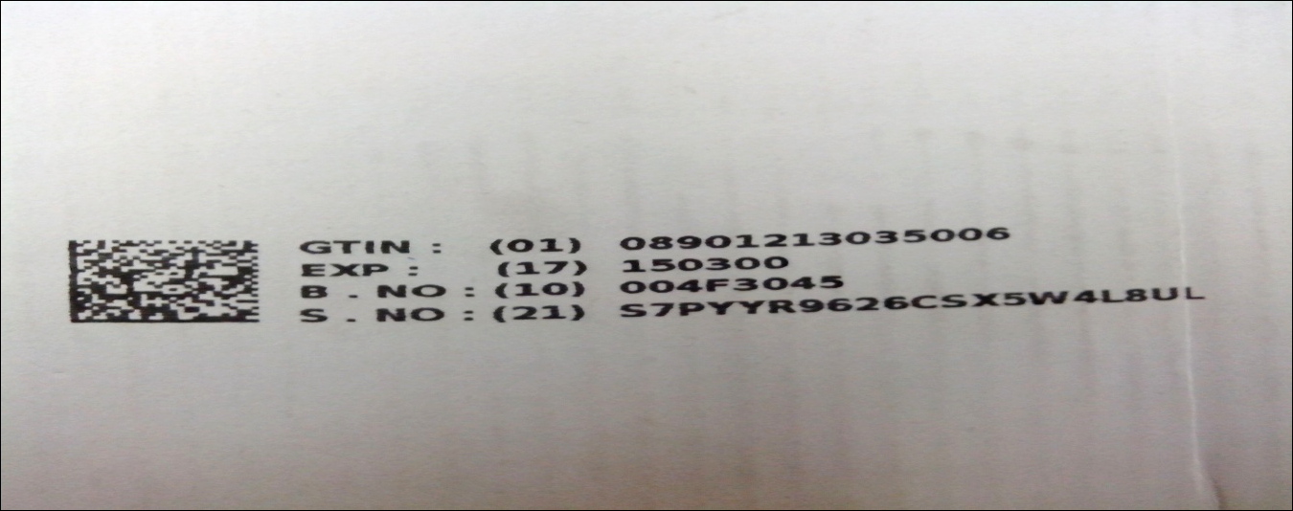

Given below barcode will result after scanning:

01089012130350061715030010004F304521S7PYYR9626CSX5W4L8UL

3rdto16th Character: GTIN 08901213035006

19th to 25thCharacter: Expiry date150300

27thto35hCharacter: Batch No. 004F3045

38th Character to end: Serial Number: S7PYYR9626CSX5W4L8UL

## 1D Non-GS1 or Standard Barcodes

Some vaccines packages contain Batch No. & Expiry Date as Non-GS1 or standard barcodes.

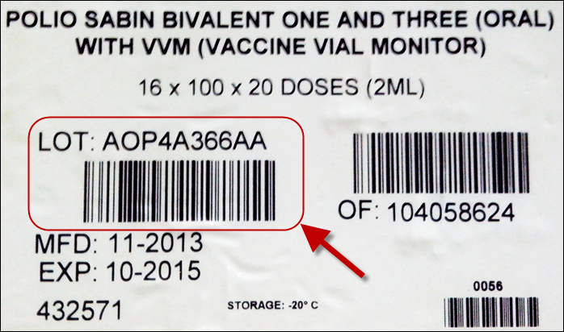

Some vaccines packages contain Batch/Lot No as Non-GS1 or standard barcodes.

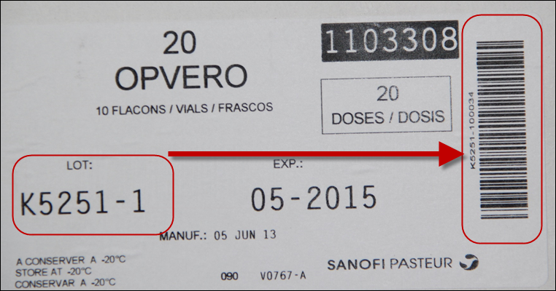

## No Barcodes

Some vaccines packages do not contains any barcodes.



## Assumptions

This manual assumes that you already have Vaccine Logistics Management Information System user accounts as per your role. This manual also assumes that you are familiar with basic web-application account login procedures.

## System Requirements

Barcode Scanner device can scan multiple types of barcodes as well as it is a small computer with windows CE Operating system. Users can access the application to store and track stock information.

## Browser Support

The following browsers and later versions fully support vLMIS standard view:

* Mozilla Firefox (Windows, Mac, Linux)
* Google Chrome (Windows, Mac, Linux)
* Netscape (Windows, Mac, Linux)
* Safari (Mac)
* Internet Explorer 9 and above (Windows)

|  |  |
| --- | --- |
| User Roles | **2** |
| of Barcode Scanner Application | |

This section explains the user accounts for barcode scanner application embedded within the vLMIS and their roles. The Barcode Scanner Application user are Vaccine Logistics Management Information System store operators that manage and record the inventory and stock transactions. Each geographical level entails different user roles associated with their warehouse / store operations.

# Barcode Scanner Application User Roles

The user roles for barcode scanning application are basically assigned to users at the national and provincial store level to manage the cold-chain logistics and inventory management activities within the vLMIS. This includes stock receive and placement, stock issue and picking, stock transfer within a warehouse, batch and product search activities.

## National User

The National user is the warehouse / store operator with the following capabilities:

|  |  |
| --- | --- |
| **Feature** | **Responsibilities** |
| **Update Tables** | Update All Tables  View Tables  Update Items  Update Item Categories  Update Items Pack Sizes  Update CCM Locations  Update Rack Information  Update Non CCM Locations  Update Placements  Update Batches  Main Menu |
| **Stock Placement** | Stock Receive through web-based vLMIS  Stock Placement through Barcode Scanner application |
| **Stock Picking** | Stock Issue through web-based vLMIS  Stock Picking through Barcode Scanner application |
| **Stock Transfer** | Stock Transfer within the warehouse / store |
| **VVM Stage** | Search VVM stage through Barcode Scanner application  Update VVM stage through Barcode Scanner application |
| **Location Status** | View location status within the warehouse / store |
| **Search** | Search a batch through Barcode Scanner application  Search a product through Barcode Scanner application |
| **Upload** | Upload offline transactions to online repository through Barcode Scanner application |

## Provincial User

The Provincial user is the warehouse / store operator with the following capabilities:

|  |  |
| --- | --- |
| **Feature** | **Responsibilities** |
| **Update Tables** | Update All Tables  View Tables  Update Items  Update Item Categories  Update Items Pack Sizes  Update CCM Locations  Update Rack Information  Update Non CCM Locations  Update Placements  Update Batches  Main Menu |
| **Stock Placement** | Stock Receive through web-based vLMIS  Stock Placement through Barcode Scanner application |
| **Stock Picking** | Stock Issue through web-based vLMIS  Stock Picking through Barcode Scanner application |
| **Stock Transfer** | Stock Transfer within the warehouse / store |
| **VVM Stage** | Search VVM stage through Barcode Scanner application  Update VVM stage through Barcode Scanner application |
| **Location Status** | View location status within the warehouse / store |
| **Search** | Search a batch through Barcode Scanner application  Search a product through Barcode Scanner application |
| **Upload** | Upload offline transactions to online repository through Barcode Scanner application |

## Administrator

The Administrator is the warehouse / store operator with the following capabilities:

|  |  |
| --- | --- |
| **Feature** | **Responsibilities** |
| **Setup Barcode** | Add Product  Setup Product Barcode  Edit / Update Product Barcode  View Product Barcode Detail |

|  |  |
| --- | --- |
| Step-by-Step | **3** |
| Process to using Barcode Scanner Application | |

This section explains the step-by-step instructions on getting started with Barcode Scanner Application. In this section, you will learn about:

1. Barcode Scanner Application User Interface.
2. Logging Into Barcode Scanner Application.
3. Barcode Scanner Application menu and sub-menu.

# Barcode Application Login

Users can log into the Barcode Scanner application and select options from the main menu perform stock tracking using Barcode Scanner application. Users can log into the Barcode Scanner Application using the web-based vLMIS user credentials to place or pick stock.

|  |  |
| --- | --- |
| *C:\Users\isbah.zulfiqar\Desktop\1382615592_file_edit.png* | **Before You Begin...**  Make sure that you have your correct login credentials. When you register with vLMIS, the accounts and its related details along-with the login domain details will be provided to you by the vLMIS Administrator. |

**Login**

Users can login and perform inventory management operations using the barcode scanner. User must provide the related Username and password to log into the vLMIS App using the Barcode Scanner.

To log into vLMIS App, enter the username and password and click **Log In** button to log into the application as shown in the image below:

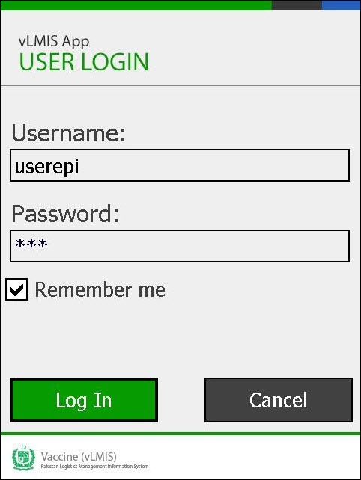

|  |  |
| --- | --- |
| *C:\Users\isbah.zulfiqar\Desktop\1382615592_file_edit.png* | User can also check the **Remember me** checkbox to store the login credentials and log into the application automatically the next time. |

|  |  |
| --- | --- |
|  | Never give out your password to anyone for security purposes. |

The login will fail if incorrect login credentials are provided and it will show login failure message as **“Invalid username or password”.**

Click the **Cancel** button to cancel application.

## Main Menu

Once a user successfully logs into the vLMIS App for Barcode Scanning, the main menu screen displays.

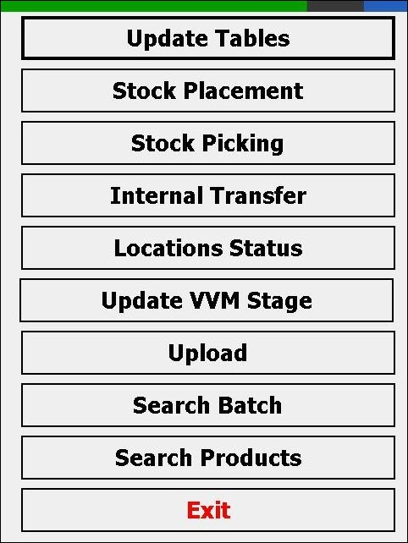

User can select different options to perform stock related operations:

* To synchronize data with web vLMIS, click ***Update Tables.***
* To place stock, click ***Stock Placement.***
* To pick stock click ***Stock Picking.***
* To Transfer stock from one location to another location, click ***Internal Transfer.***
* To view locations status, click ***Locations Status.***
* To upload offline transactions to live vLMIS, click ***Upload.***
* To update batch VVM stage, click ***Update VVM Stage.***
* To search batch locations, click ***Search Batch.***
* To search products locations, click ***Search Products.***
* To close the application, click ***Exit.***

## Sub Menu

When the user clicks the **Update Tables** tab from the main menu, a sub menu screen displays.

**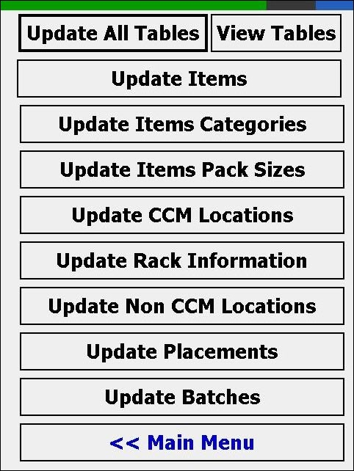**

User can select different options to update tables:

* To update all tables present on the screen, click ***Update All Tables.***
* To view the available tables, click ***View Tables.***
* To update items in the stock, click ***Update Items.***
* To update item categories in the stock, click ***Update Item Categories.***
* To update pack sizes of the items in the stock, click ***Update Items Pack Sizes.***
* To update CCM locations of the stock, click ***Update CCM Locations.***
* To update rack information for stock placement, click ***Update Rack Information.***
* To update Non CCM locations of the stock, click ***Update Non CCM Locations.***
* To update placement of the items in the stock, click ***Update Placements.***
* To update batches of the stock, click ***Update Batches.***
* To go back to the main menu, click ***Main Menu.***

|  |  |
| --- | --- |
| Stock Tracking | **4** |
| Process in Barcode Scanner Application | |

This section explains the stock tracking and location management process in the inventory using Barcode Scanner Application.

# National and Provincial User

National and Provincial users can log into the Barcode Scanner Application using the web-based vLMIS user credentials to place or pick stock. There are **two** parts of **Stock Tracking Using Barcode Scanner** application, one part is performed using **vLMIS web-based application** and other part is performed using **Barcode Scanner application.**

## Stock Placement

When Shipment is received within business hours, users can enter **Stock Details** using vLMIS Web-based application and then **Place Stock** using **Barcode Scanner** **Application** (vLMIS App). In case user wants that each **Product** and Its **Barcode** related details is registered only once, s/he canuse vLMISweb-basedapplication to update data and Barcode details can be used to get ***Product Batch and Expiry*** details using **Barcode Scanner** Application (vLMIS App).

### **Stock Receive (vLMIS web-based Application)**

The EPI user (National and Provincial) can receive stock from suppliers and then distribute the stock to the Provincial, District and Tehsil stores on demand.

**From Supplier:**

To receive stock from supplier:

1. Sign in to the user account.  
   The User Home Page displays.
2. Under **Inventory Management**, click **Stock Receive (Supplier)**.

The Stock Receive from Supplier screen displays.

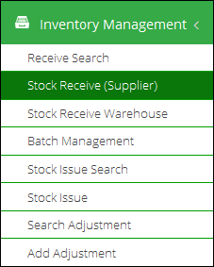

1. The Stock Receive from Supplier screen displays.  
   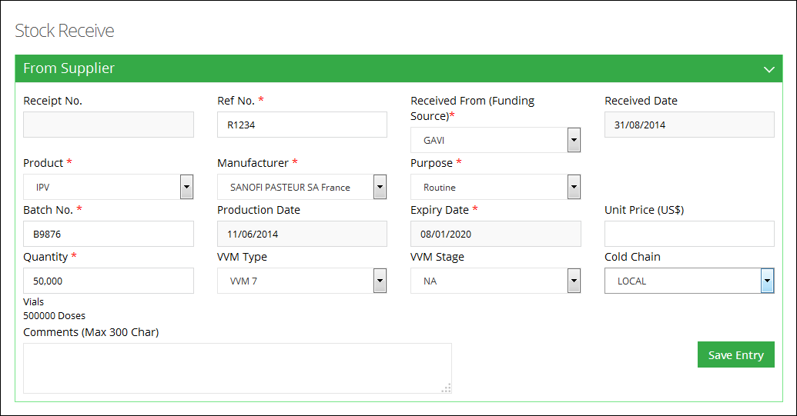
2. Specify the following information:
   * **Receipt No**: is an automatically generated number for identifying the receive transaction.
   * **Ref No.**: specify the reference number.
   * **Received Date:** Click on Receive date to expand the date picker tool.   
       
     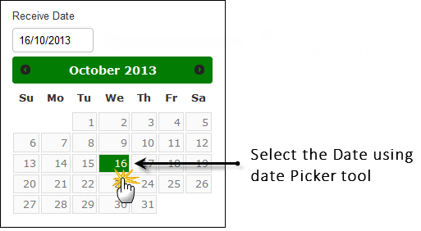
   * **Received From (Funding Source)**: Select the supplier for the product.
   * **Product**: select the product from the list.
   * **Manufacturer:** select the manufacturer from the list.
   * **Purpose:** specify the purpose of stock receive. If the selected purpose is campaign, specify the campaign for which stock is required.
   * **Batch No:** specify the batch number for the product.
   * **Production Date:** Click on Production date to expand the date picker tool, or type-in the required date using format dd/mm/yyyy.
   * **Expiry Date:** Click on Expiry date to expand the date picker tool, or type-in the required date using format dd/mm/yyyy.
   * **Unit Price:** specify the price in US$.
   * **Quantity:** specify the quantity of the product.
   * **VVM Type:** specify the VVM (Vaccine Vial Monitor) Type.
   * **VVM Stage:** specify the VVM stage.

|  |  |
| --- | --- |
| C:\Users\isbah.zulfiqar\Desktop\1382615592_file_edit.png | A vaccine vial monitor (VVM) is a label containing a heat-sensitive material which is placed on a vaccine vial to register cumulative heat exposure over time. The combined effects of time and temperature cause the inner square of the VVM to darken, gradually and irreversibly. A direct relationship exists between the rate of color change and temperature:  The lower the temperature, the slower the color change, the higher the temperature, the faster the color change. |

* + **Cold Chain:** select the cold-chain.

1. Click **Save Entry** for details.

The entry moves to the Issue List. You can add new entries, as required. All of the entries will be displayed in the Issue List.  
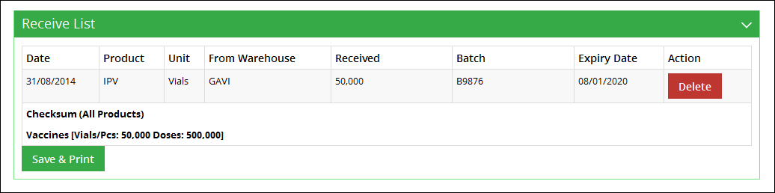

1. Click **Save & Print**.  
   The Receive voucher is saved and printed.

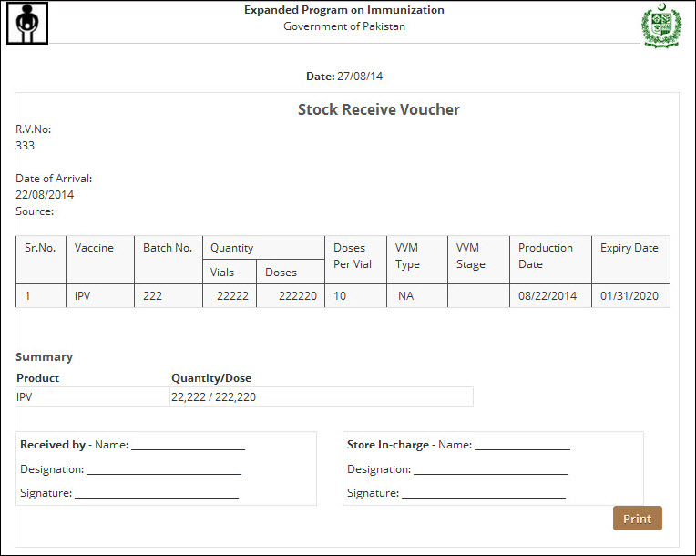

**From Warehouse:**

National, Provincial, District and Tehsil user can also receive stock from other warehouses of lower geographical levels e.g. Central Store can receive stock from Provincial store. The stock might be returned to the upper geographical level based on requirements.

To receive stock from warehouse:

1. Sign in to the user account.  
   The User Home Page displays.
2. Under **Inventory Management**, click **Stock Receive (Warehouse)**.

The Stock Receive from Warehouse screen displays.

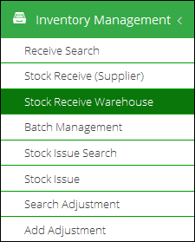

1. Add **Issue Number** to search for the required entry in database.  
     
   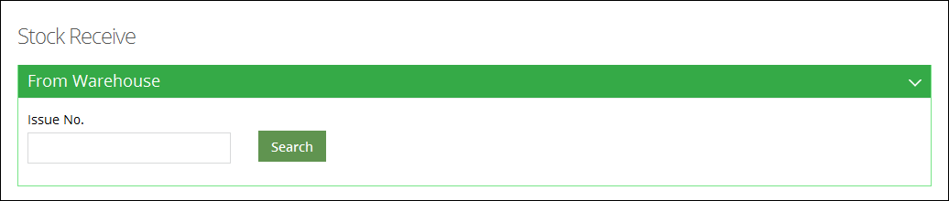

The required issued entry displays.

1. Review the issued product’s details. The table includes:
   * **Product**: displays the product name.
   * **Batch:** displays the batch number for the product.
   * **Quantity:** displays the issued quantity.
   * **VVM Stage:** displays the VVM stage.

|  |  |
| --- | --- |
| C:\Users\isbah.zulfiqar\Desktop\1382615592_file_edit.png | A vaccine vial monitor (VVM) is a label containing a heat-sensitive material which is placed on a vaccine vial to register cumulative heat exposure over time. The combined effects of time and temperature cause the inner square of the VVM to darken, gradually and irreversibly. A direct relationship exists between the rate of color change and temperature:  The lower the temperature, the slower the color change, the higher the temperature, the faster the color change. |

* + **Adjusted Quantity:** if the received quantity is different than the issued quantity, you can enter the adjusted quantity in this text box.
  + **Adjustment:** specify the adjustment type:
  + **Receive Reference**: specify the receive reference.
  + **Receive Date:** Click on Receive date to expand the date picker tool and specify the received date.

1. Check the  icon in the end of the row and then click **Save**.  
   The entry is received and added to the inventory.
2. Click **Print**.  
   The Receive voucher is printed.

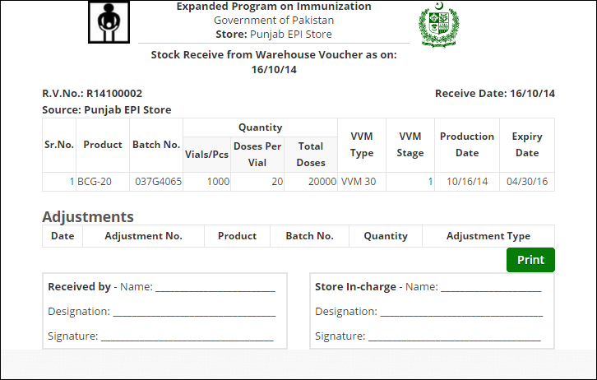

### **Stock Placement (Barcode Scanner Application)**

To place received stock (using vLMIS web application as shown above) at a location within the warehouse / store:

1. Select **Stock Placement** option from the main menu.

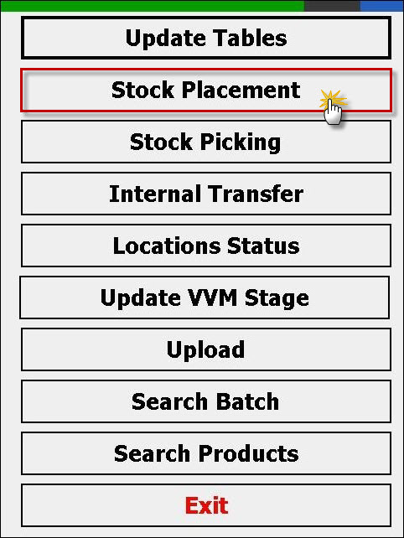

Stock Placement screen will be displayed.

1. Select a receive voucher number and it will display products against selected receive voucher number.

Users have an option to select a particular receive voucher number from the drop-down menu as shown below:

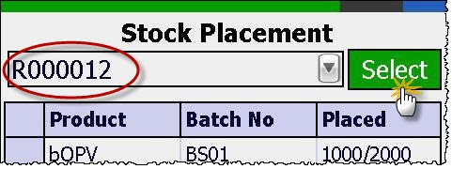

1. Users can also select a receive voucher number from the complete list with details. Click **Select** to view the list as shown below:

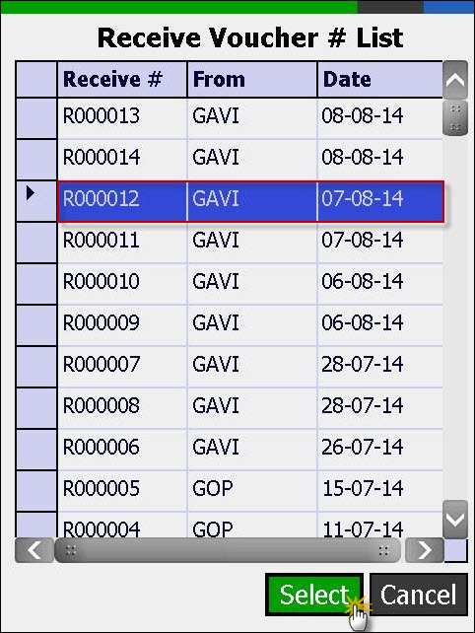

1. A list of products will be displayed against the selected receive voucher number.

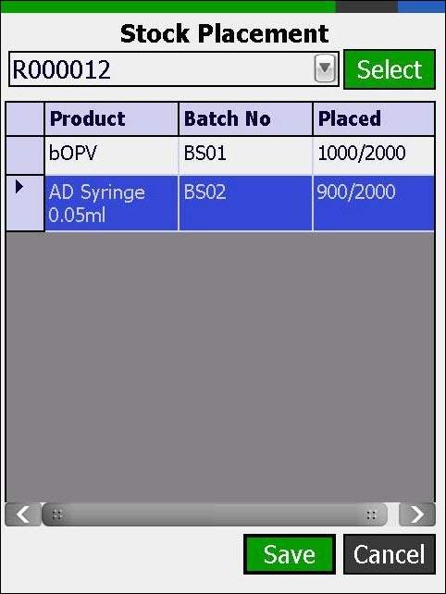

1. Double click each product from grid to place it at a particular location.

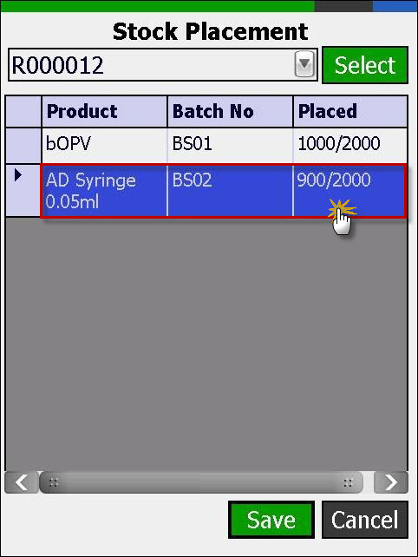

1. Select or Scan location where product needs to be placed and click **Select**.

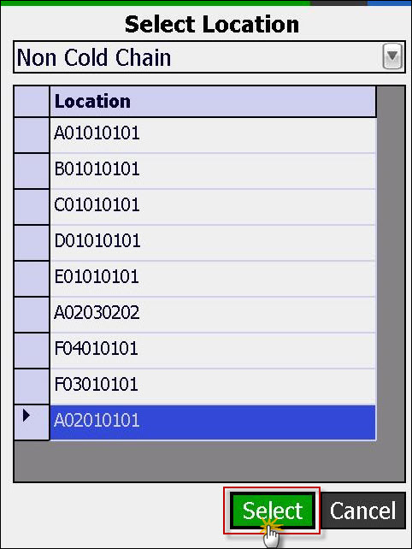

1. Scan the batch of the stock or select manually.
2. Enter quantity of the product to be placed on selected location and click **Add**. By default, quantity is selected as 1. To change the quantity of stock, uncheck the Qty = 1 box and add the quantity of the product manually.

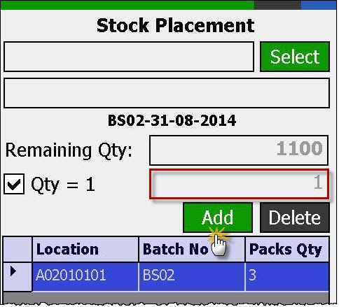

1. Repeat the above step to place more stock at the selected location.
2. Repeat step 2 through 8 to place other products.
3. Once done with the placement, click **OK** to place the stock.

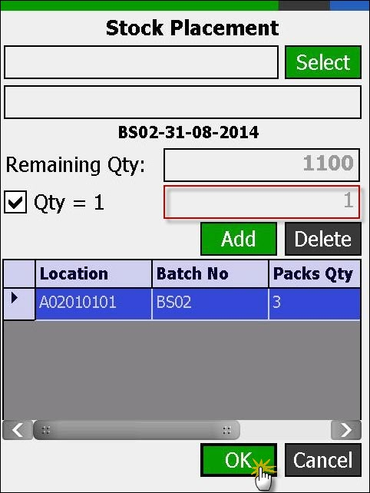

1. Upload Transactions to vLMIS web-based application in real-time whenever Internetconnectivity is available.

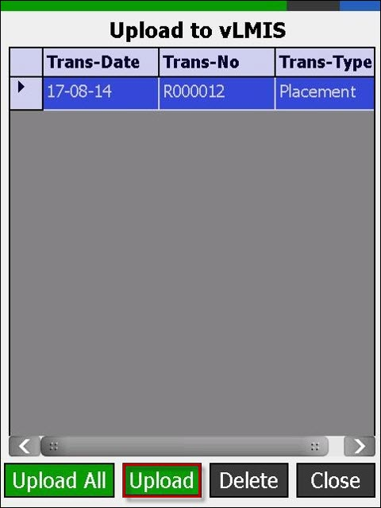

## Stock Picking

Users can **pick and issue** stock using barcode scanner application after creating an issue voucher using the vLMIS web-based application. User can make sure that **First Entry First Out** **(FEFO)** process is followed while issuing stock to any other EPI store.

### **Stock Issue (vLMIS web-based Application)**

National, Provincial and District users can issue stock to other warehouse/stores. Stock can be issued directly to the stores / facilities.

To issue stock:

1. Sign in to the user account.  
   The User Home Page displays.
2. Under **Inventory Management**, click **Stock Issue**.

The New Issue page displays.   
  
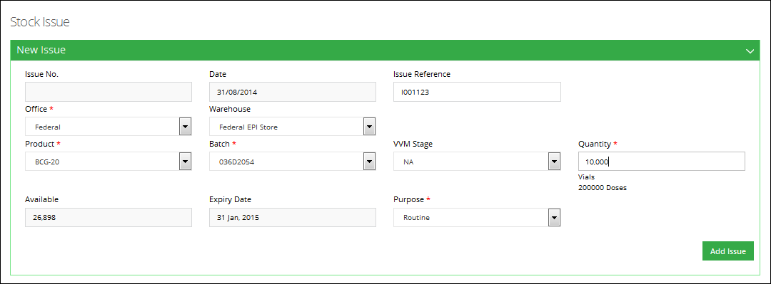

1. In order to issue a vaccine batch, specify the following information:
   * **Issue No**: is an automatically generated number for identifying the issue transaction.
   * **Date:** Click on date to expand the date picker tool.   
       
     
   * **Issue Reference**: specify the receive reference.
   * **Office**: In this drop-down, select the office to which you want to issue the product. On selecting the **Office**, the **Province** drop-down is displayed. On selecting the Province, the **Issue To** drop-down displays the relevant warehouse store names in the selected province. Select the required warehouse/store.
   * **Product**: select the product from the list.
   * **Batch:** specify the batch number for the selected product.
   * **VVM Stage:** specify the VVM stage.

|  |  |
| --- | --- |
| C:\Users\isbah.zulfiqar\Desktop\1382615592_file_edit.png | A vaccine vial monitor (VVM) is a label containing a heat-sensitive material which is placed on a vaccine vial to register cumulative heat exposure over time. The combined effects of time and temperature cause the inner square of the VVM to darken, gradually and irreversibly. A direct relationship exists between the rate of color change and temperature:  The lower the temperature, the slower the color change, the higher the temperature, the faster the color change. |

* + **Quantity:** specify the issue quantity. Make sure it is less than the available quantity of the batch.
  + **Available:** displays the available quantity.
  + **Expiry Date:** Click on Expiry date to expand the date picker tool, or type-in the required date using format dd/mm/yyyy.
  + **Purpose:** Add the purpose for which stock is being issued. In case of a campaign, the name of the campaign should also be specified.

1. Click **Add Issue** to add the issue entry to the Issue list.  
     
   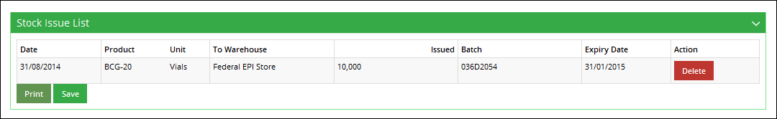
2. Click **Save**.  
   The Issue entry is saved.
3. Click **Print** to print the Issue Voucher.

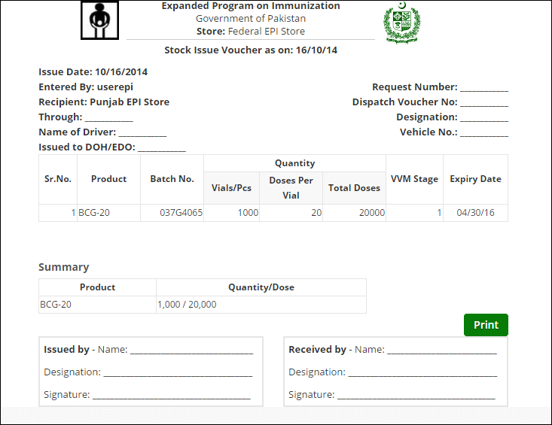

### **Stock Picking (Barcode Scanner Application)**

To pick issued stock (using vLMIS web application as shown above) from a location within the warehouse / store:

1. Select **Stock Picking** option from the main menu.

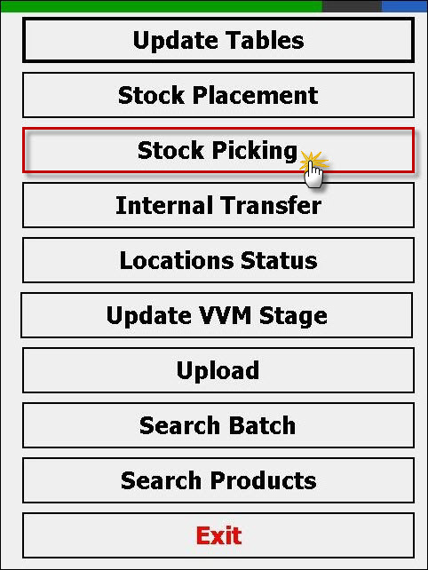

Stock Picking screen will be displayed.

1. Select a Stock Issue Voucher and it will display products against selected issue voucher number.

Users have an option to select a particular issue voucher number from the drop-down menu as shown below:

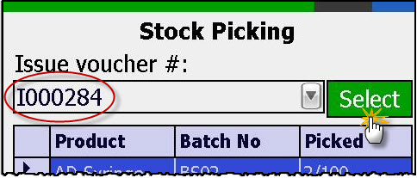

1. Users can also select an issue voucher number from the complete list with details. Click **Select** to view the list as shown below:

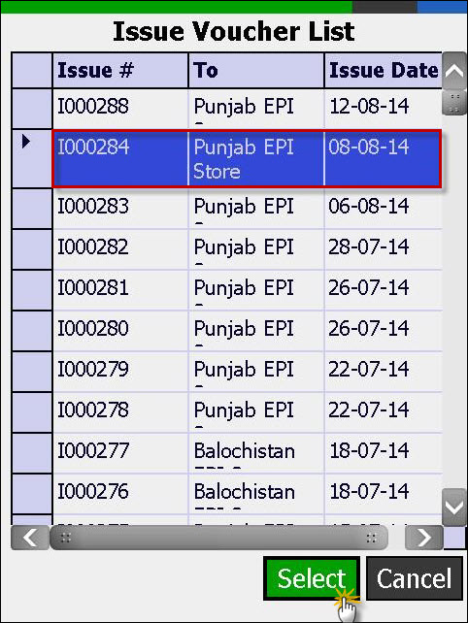

1. A list of products will be displayed against the selected issue voucher number.

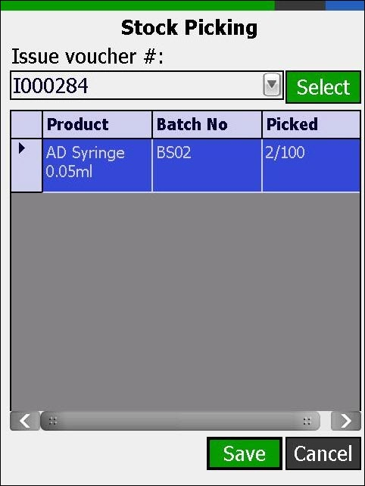

1. Double click each product from grid to place it at a particular location.

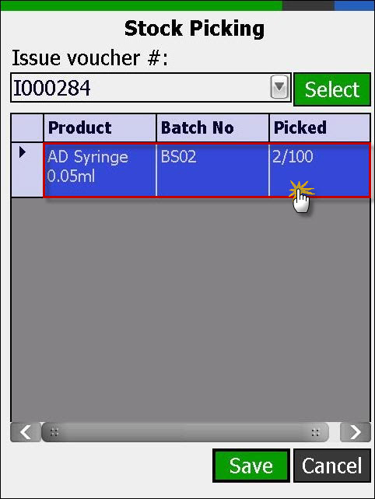

1. Select or Scan location from where product needs to be picked and click **Select**.

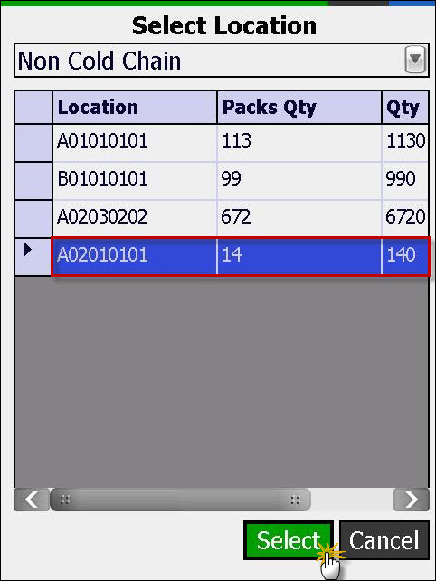

1. Enter quantity of the product to be picked from a selected location and click **Add**. By default, quantity is selected as 1. To change the quantity of stock, uncheck the **Qty = 1** box and add the quantity of the product manually.

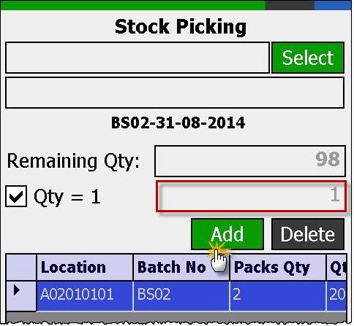

1. Press **Esc** key to close Stock Picking screen and record in Stock Picking grid will be updated.
2. Repeat step number 2 through 7 to issue and pick other products.
3. Once done with stock picking, click **OK**.

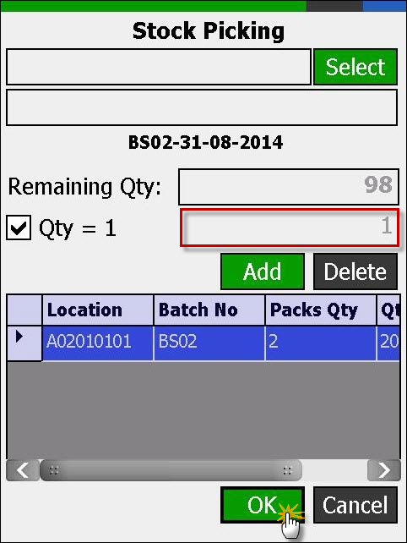

1. Click **Save** button to save all records or **Cancel** to close Stock Picking screen.
2. Upload Transactions to live **vLMIS Web Site,** whenever internet connectivity is available.

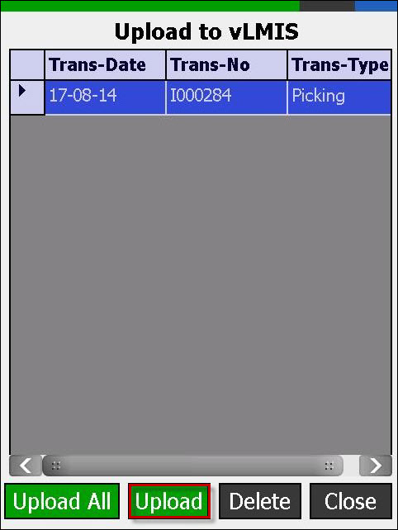

## Stock Transfer

Users can **transfer** stock after being placed within the warehouse / store using barcode scanner application using the vLMIS web-based application.

### **Location Status (vLMIS web-based Application)**

EPI National and Provincial Users can select **Vaccine Location** and **Non-Vaccine Location** to show a particular location for allocating the stock.



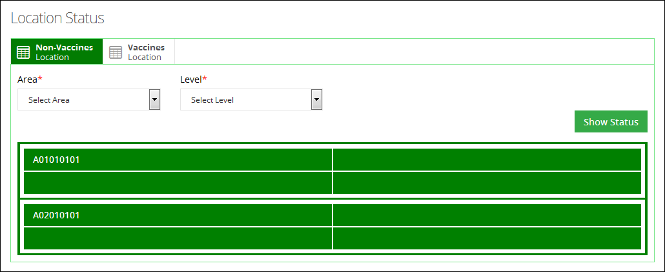

Click a particular location. The status of that location will appear and the details of the product present at that location will appear.

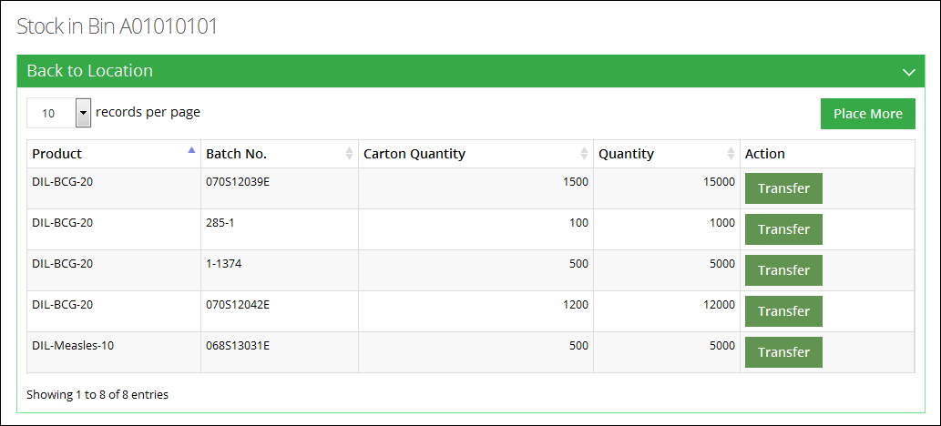

In order to transfer the stock available at this location, click **Transfer.** A new window will pop-up.

* Select the location to transfer stock.
* Add quantity of boxes. (The quantity of boxes to transfer should be less than or equal to the available number of boxes.)
* Click **Transfer.**

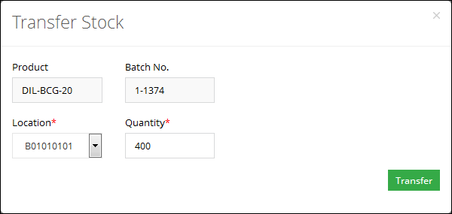

To add more stock to this location, click **Place More.** A complete list of received stock will be displayed.

Add **Place Quantity** and click **Save.**

**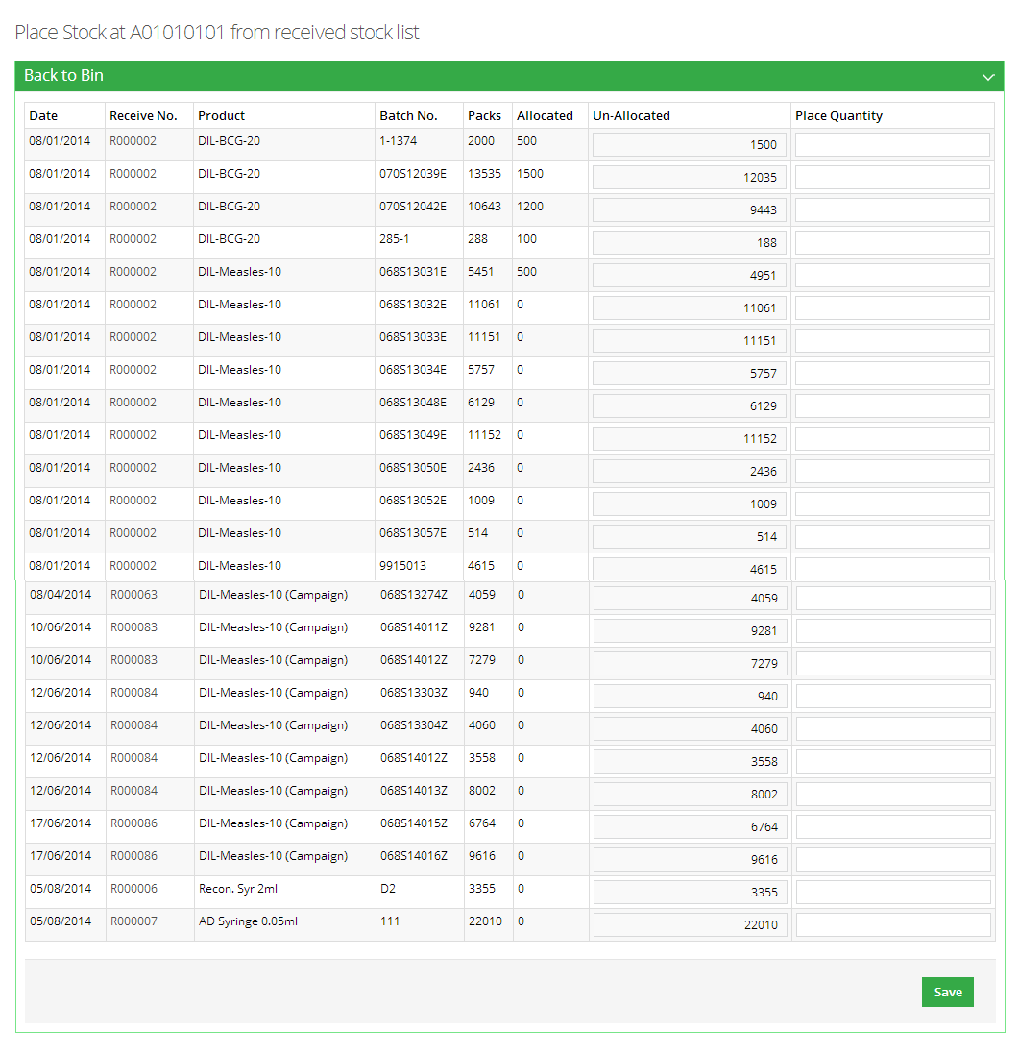**

### **Internal Transfer (Barcode Scanner Application)**

National and Provincial users can **Transfer** stock from one Location to another within the **EPI Store**. This internal transfer of stock from one location to another location can be performed using a barcode scanner.

To transfer stock from a location within the warehouse / store:

1. Select **Internal Transfer** option from the main menu.

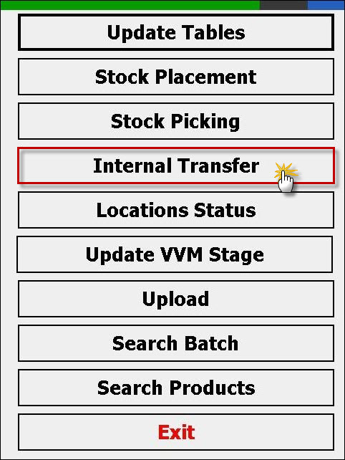

Internal Transfer screen will be displayed.

1. Select or scan the source location.

Users have an option to select a particular location from the drop-down menu as shown below:

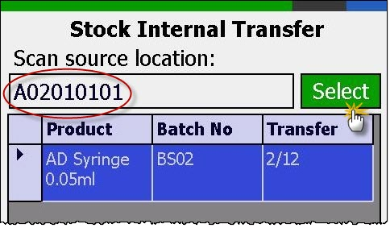

1. Users can also select the source location from the complete list with details. Click **Select** to view the list as shown below:

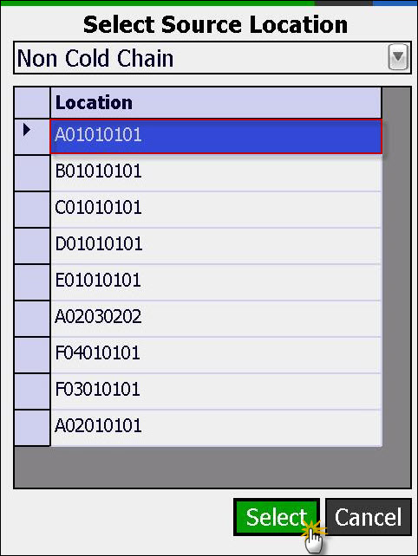

1. A list of products will be displayed against the selected issue voucher number.

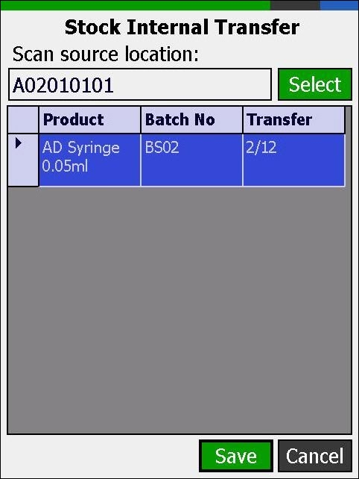

1. Double click the product from grid to transfer it at another location.

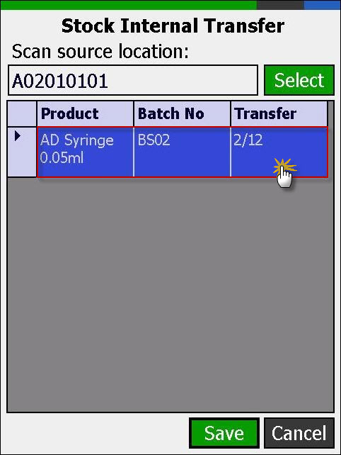

1. Enter quantity of the product to be transferred from the source location and click **Add**. By default, quantity is selected as 1. To change the quantity of stock, uncheck the **Qty = 1** box and add the quantity of the product manually.



1. Press **Esc** key to close Stock Picking screen and record in Stock Picking grid will be updated.
2. Repeat step number 2 through 7 to issue and pick other products.
3. Once done with selecting batches, click **OK**.



1. Select or Scan the target location to transfer stock and click **Select**.

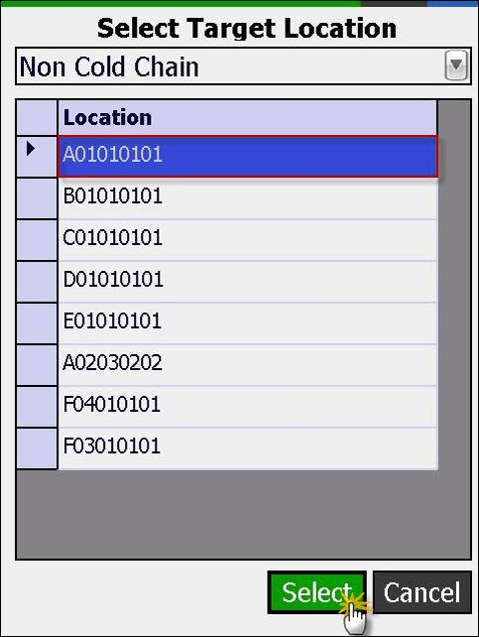

1. Click **Save** button to save all records or **Cancel** to close Internal Transfer screen.
2. Upload Transactions to live **vLMIS Web Site,** whenever internet connectivity is available.

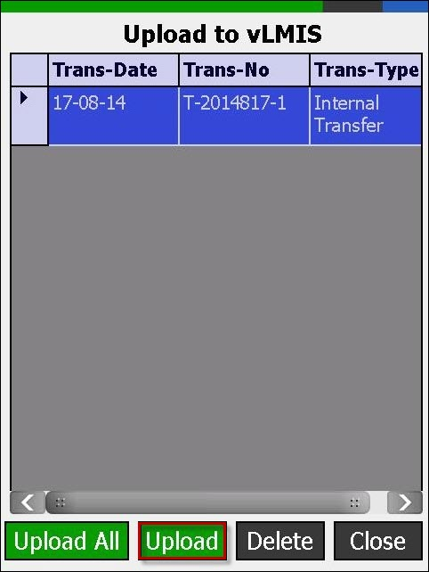

## Locations Status

Users can view the **Locations Status** of a particular product within EPI store using **Barcode Scanner** application. User can view locations status to check the filled and available space in any particular location.

### **Location Status (vLMIS web-based Application)**

EPI Users can select **Vaccine Location** and **Non-Vaccine Location** to show a particular location for allocating the stock.





Click a particular location. The status of that location will appear and the details of the product present at that location will appear.



### **Location Status (Barcode Scanner Application)**

User can view **Location Status** of a particular product present at a particular location using a barcode scanner.

To view the location status of the stock:

1. Select **Locations Status** option from the main menu.

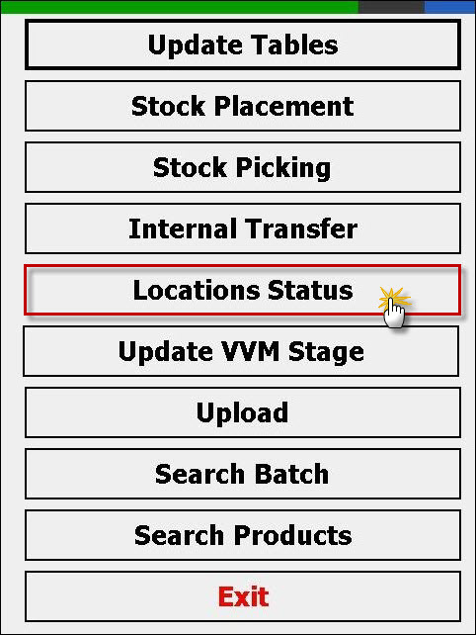

1. Locations Status screen will be displayed.

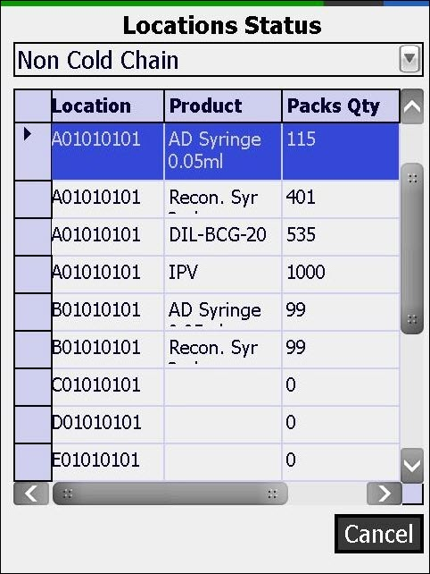

1. Locations status for all the products will be shown in the grid.

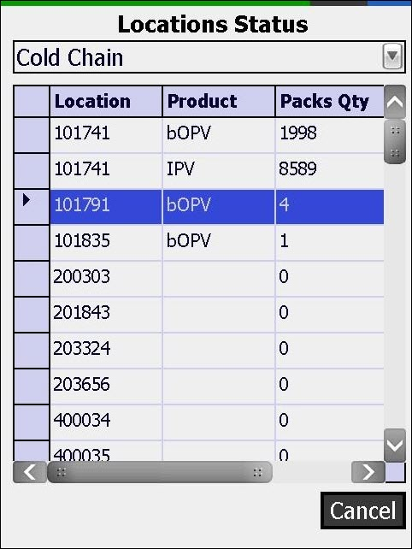

1. Click Cancel button to close Locations Status screen.

## VVM Stage

Users can **Search** as well as **Update** the **VVM Stage** of particular **Batch** of the product placed at a particular location within EPI store using **Barcode Scanner** application.

### **Set VVM Stage (vLMIS web-based Application)**

National and Provincial users can issue stock to other warehouse/stores. Stock can be issued directly to the stores / facilities. When a user issues stock, the option to set VVM stage for the stock being issued is provided within the vLMIS.

To set the VVM stage:

1. Sign in to the user account.  
   The User Home Page displays.
2. Under **Inventory Management**, click **Stock Issue**. The New Issue page displays.  
     
   
3. **VVM Stage:** specify the VVM stage.

|  |  |
| --- | --- |
| C:\Users\isbah.zulfiqar\Desktop\1382615592_file_edit.png | A vaccine vial monitor (VVM) is a label containing a heat-sensitive material which is placed on a vaccine vial to register cumulative heat exposure over time. The combined effects of time and temperature cause the inner square of the VVM to darken, gradually and irreversibly. A direct relationship exists between the rate of color change and temperature:  The lower the temperature, the slower the color change, the higher the temperature, the faster the color change. |

1. Select the VVM stage from the following options:
   * **NA:** Not applicable
   * **1 (Usable):** is the VVM stage 1 and is considered usable.
   * **2 (Usable):** is the VVM stage 1 and is considered usable.
   * **3 (Not Usable):** is the VVM stage 1 and is considered not usable.
   * **4 (Not Usable):** is the VVM stage 1 and is considered not usable.

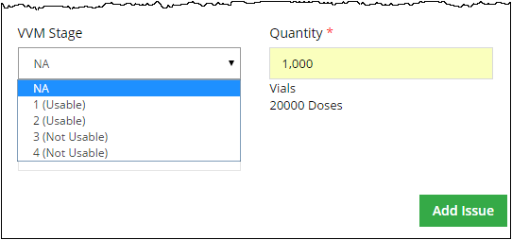

### **Update VVM Stage (Barcode Scanner Application)**

User can update VVM stage of a particular product present at a particular location using a barcode scanner.

To update the VVM stage of the stock:

1. Select **Update VVM Stage** option from the main menu.

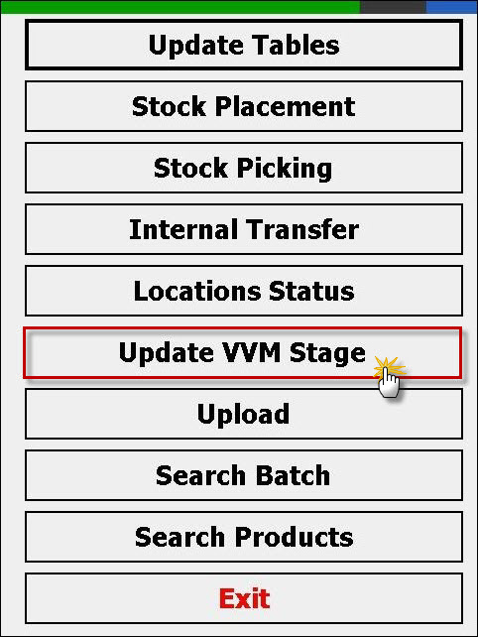

Update VVM Stage screen will be displayed.

1. Select or scan the batch number.

Users have an option to enter the batch number from the drop-down menu.

Users can also select the batch number from the complete list of batches for a single product with details. Click **Select** to view the list as shown below:

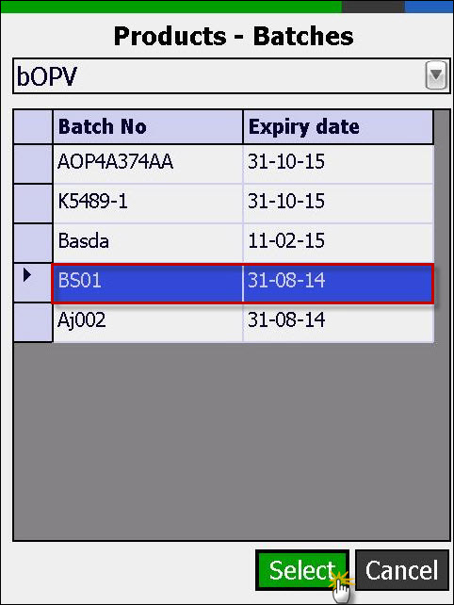

1. The selected batch will be searched and all records will be populated in grid.
2. Change the VVM Stage by selecting value from **VVM Stage** combo box.

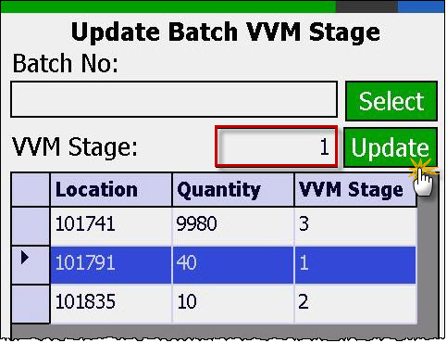

1. Click **Save** button to save changes.

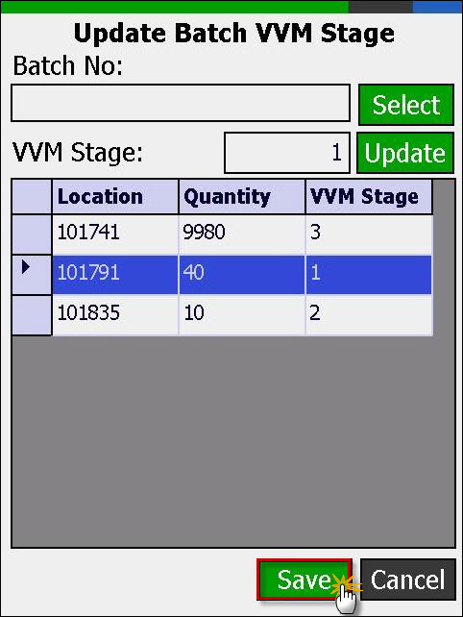

## Search Batch

Users can **Search** particular **product Batch** placed on **all locations** within EPI store using **Barcode Scanner** application.

### **Batch Management (vLMIS web-based Application)**

Once the vaccines stock is received in warehouse, each package is identified by its Batch Number and Expiry Date. Each batch is sorted by its expiry date by the rule of “First Expiry First Out”. When batches are added to vLMIS, the account user usually assigns the batches with latest expiry date as ‘Running’. The running batches are issued first.

To Manage Batches:

1. Sign in to the user account.  
   The User Home Page displays.
2. Under **Inventory Management**, click **Batch Management**.

The Batch Management page displays. You can print the list of available stock by clicking **Summary.**

1. In order to mark the status of the batch, you can specify search criteria to search for the required batch as follows:
   * **Vaccine**: select the required vaccine from the list.
   * **Status**: specify the status of the batch that you are searching for.

* **Running**: Only the batches with the status “Running” can be issued.
* **Stacked**: Stacked batches represent that they are stacked in the warehouse and cannot be issued.
* **Finished**: batches have finished.
  + **Batch No.**: Optionally, specify the Batch No of the required batch.
  + **Ref. No.**: Optionally, specify the Ref. No. of the required batch.

1. Click **Search**.  
   The Search results are displayed in a table.

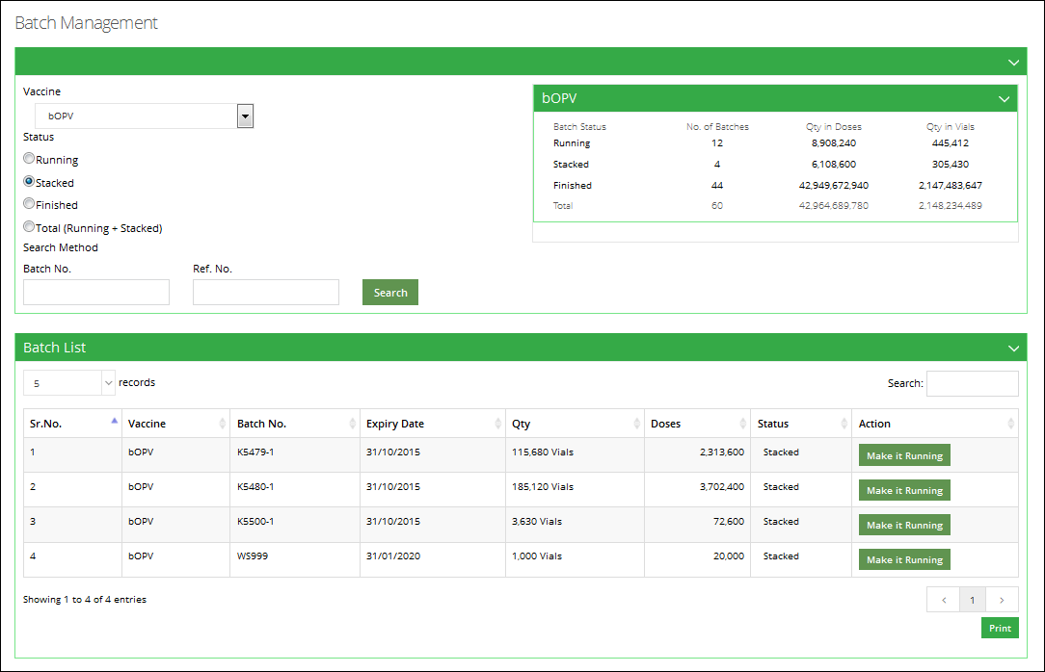

1. You can review the batch status and change it by clicking the button adjacent to it.

|  |  |
| --- | --- |
| C:\Users\isbah.zulfiqar\Desktop\1382615592_file_edit.png | Remember that in order to issue batches, you have to first set their status to ‘Running’. |

### **Search Batch (Barcode Scanner Application)**

User can search **Batch** of a particular product present at a particular location using a barcode scanner.

To search **Batch** of the stock:

1. Select **Search Batch** option from the main menu.

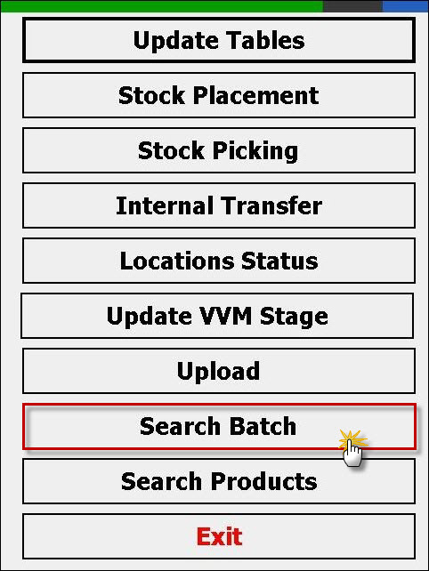

Search Batch screen will be displayed.

1. Enter batch number or click **Select** button to select product and all batches will be listed in the grid.

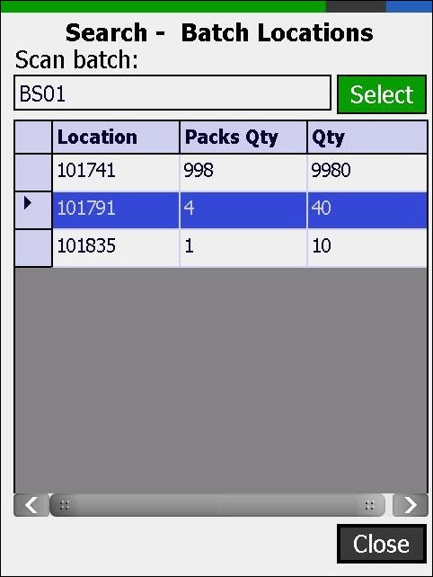

1. Users can also select batch number from grid and click a selected batch number and all locations will be shown in the grid wherever the selected batch is placed.

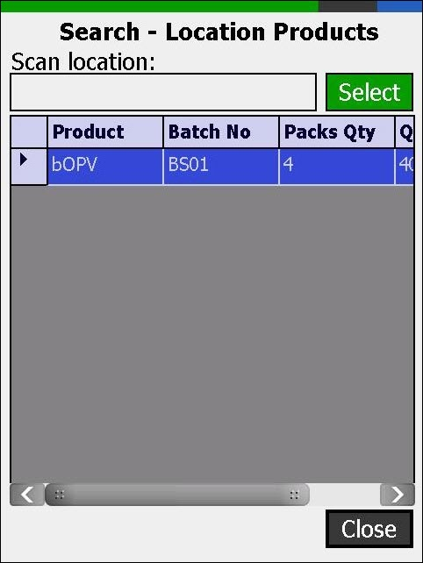

1. Click **Close** button to close Batch Locations Screen.

## Search Products

Users can **Search** products available at a particular location within EPI store using the **Barcode Scanner** application.

To search **Products**:

1. Select Search Products option from Main Menu to display Locations Products screen.

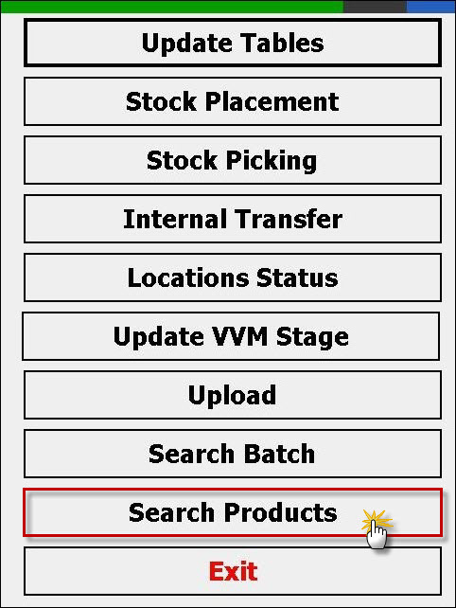

1. Enter location or click **Select** button to open Select Location screen. Select location from the list and click **Select.**

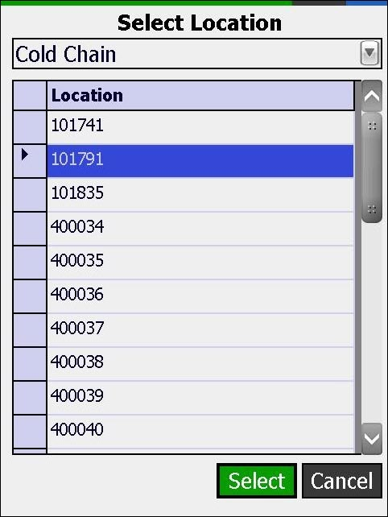

1. All products list will be loaded in the grid which are placed on the entered or selected location.

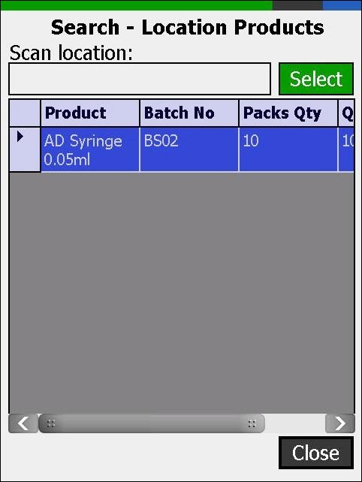

1. Click **Close** button to close Location Products screen.

## Upload

Users can also upload offline transactions to online repository using this screen on the Barcode Scanner Application.

To **Upload** transactions:

1. Select Upload option from Main Menu to display Upload to vLMIS screen.

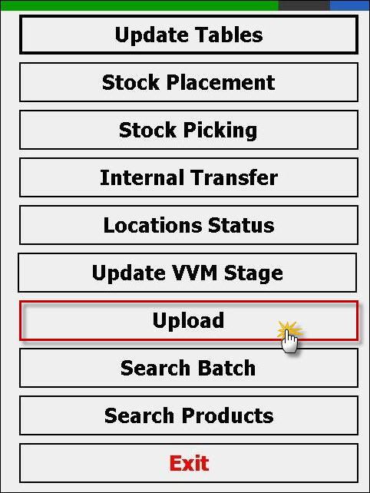

1. All pending transactions will be loaded in the grid.
2. Click Upload button to upload all pending transactions to the web-based vLMIS provided internet connection is available.





1. Click **Close** button to cancel uploading process or to close Upload to vLMIS screen.